1.)

<http://www.oracle.com/technetwork/java/javase/downloads/jdk8-downloads-2133151.html>

download “[jdk-8u171-windows-x64.exe](http://download.oracle.com/otn-pub/java/jdk/8u171-b11/512cd62ec5174c3487ac17c61aaa89e8/jdk-8u171-windows-x64.exe)”.

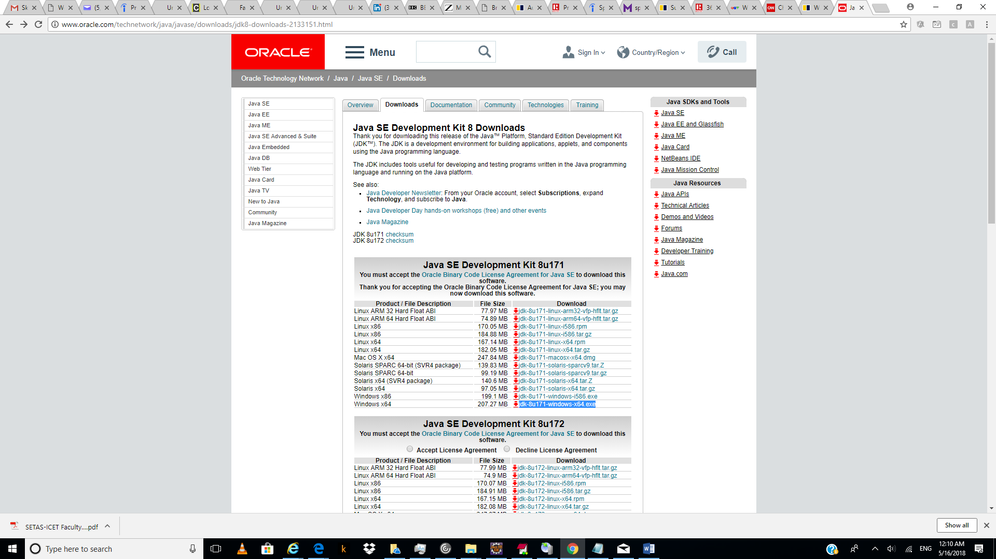

2.)

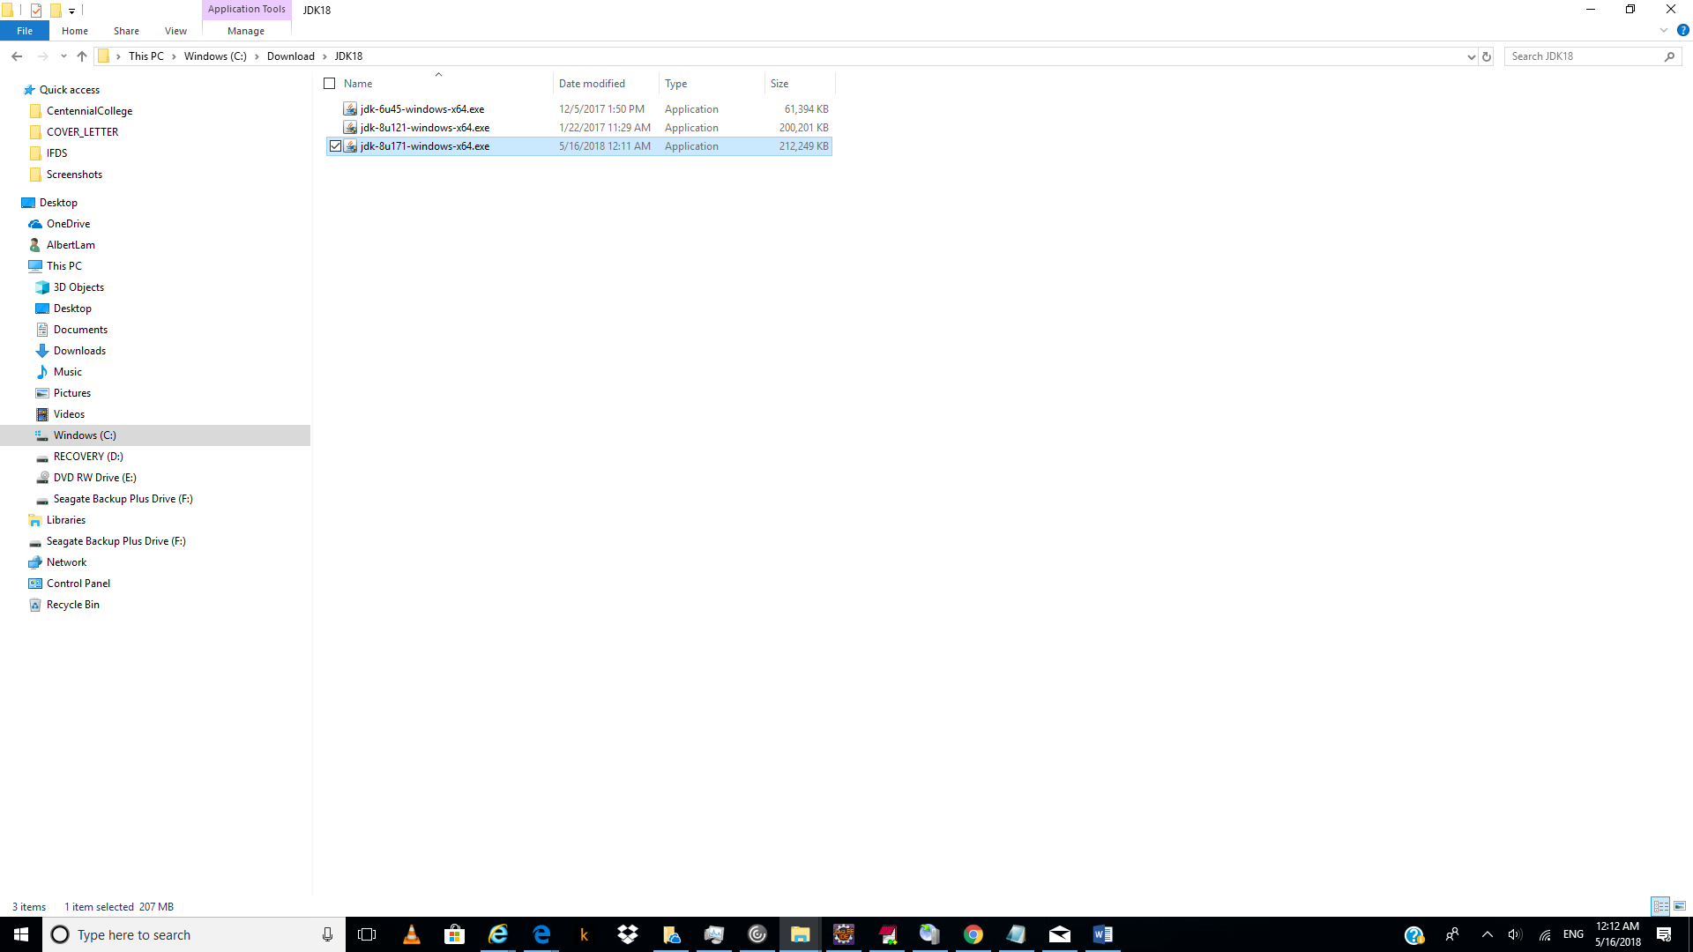

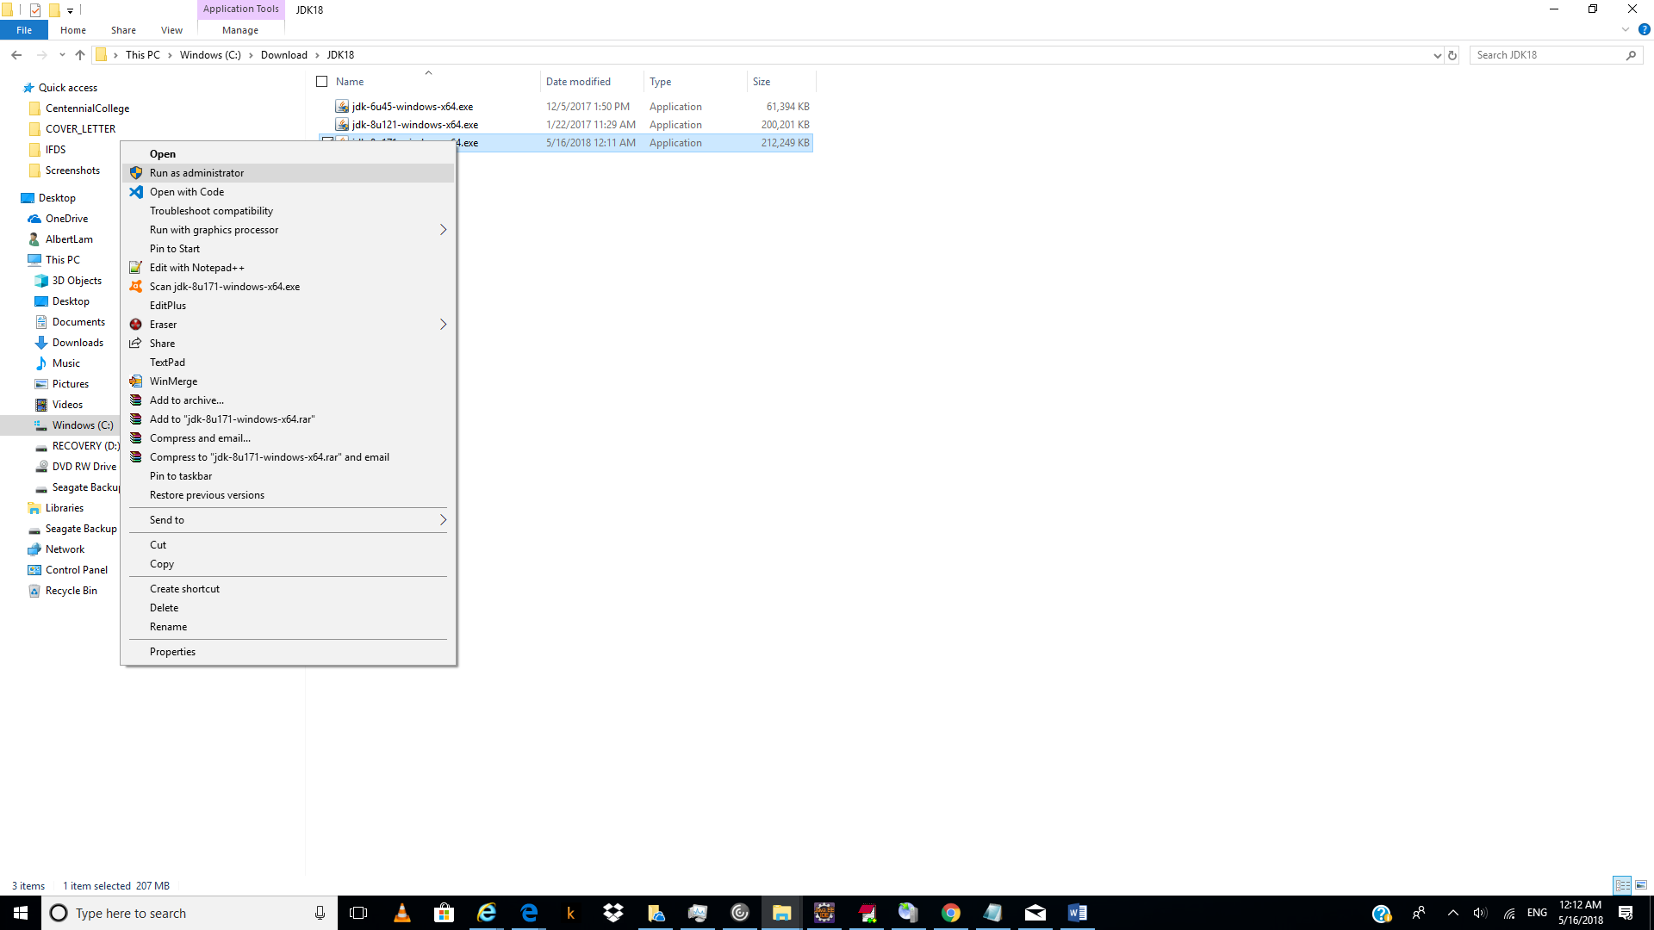

3.)

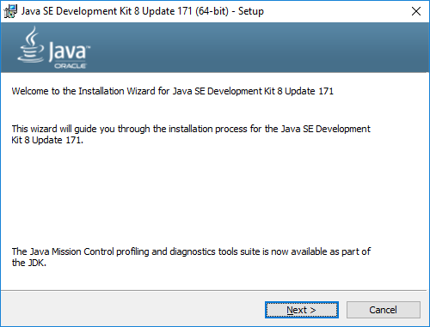

Click “next”.

4.)

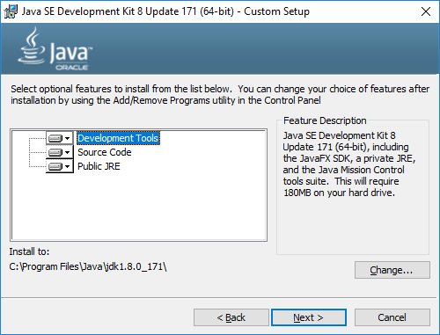

Click “Change..”.

5.)

Change from original:

C:\Program Files\Java\jdk1.8.0_171\

To:

C:\Program Files\Java\jdk18_171\

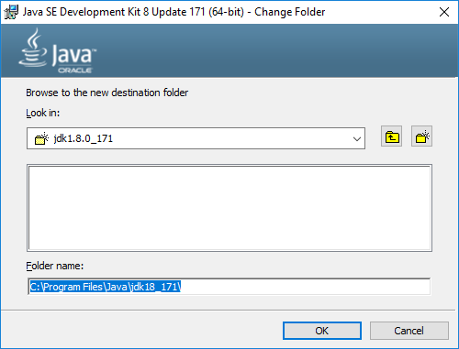

Click “OK”.

6.)

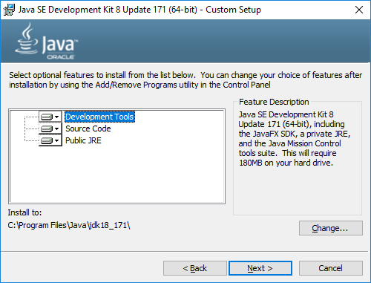

Click “Next”.

7.)

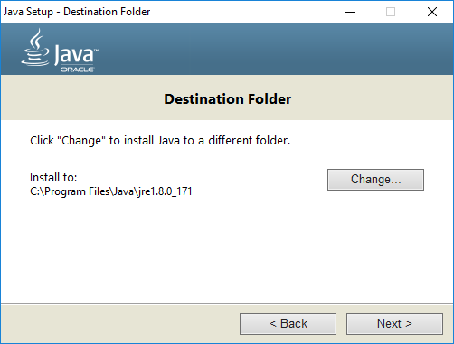

Click “change”.

8.)

Created a folder called C:\Program Files\Java\jre18_171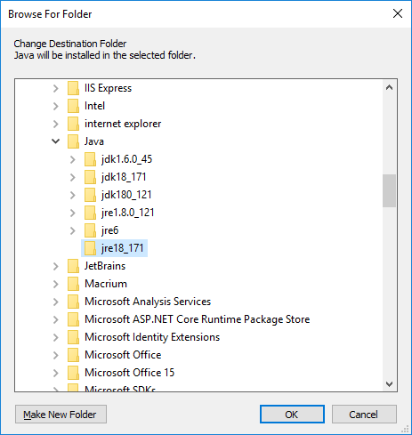

9.)

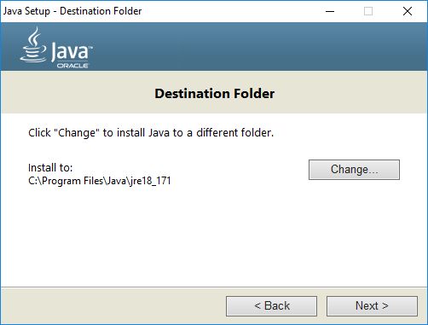

Click “Next”.

10.)

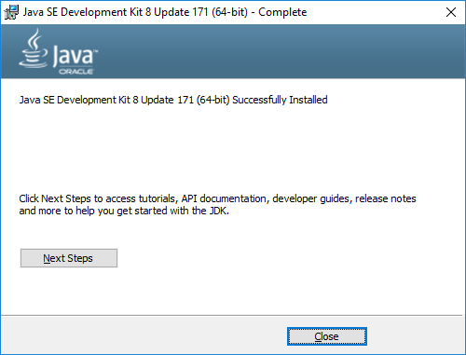

11.)

### Download “64 bite” for “[Eclipse IDE for Java EE Developers](http://www.eclipse.org/downloads/packages/eclipse-ide-java-ee-developers/oxygen3a)”

<http://www.eclipse.org/downloads/eclipse-packages/>

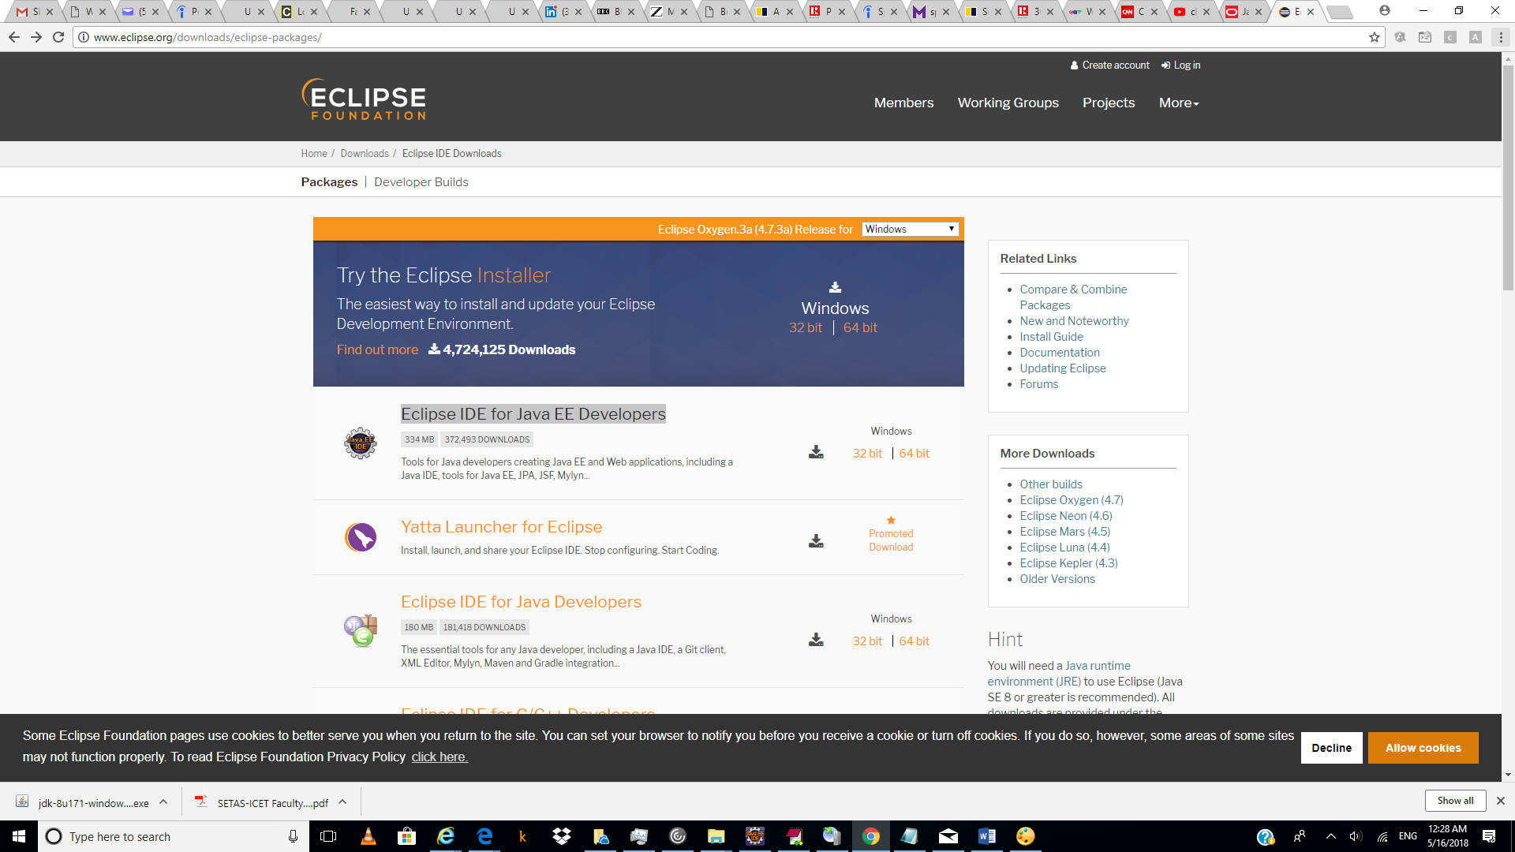

12.)

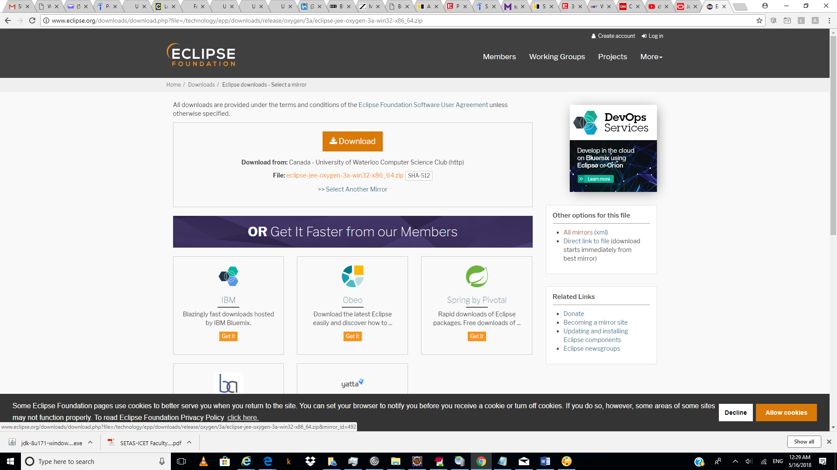

Click “download”.

13.)

Unzp eclipse-jee-oxygen-3a-win32-x86_64.zip and you get eclipse folder.

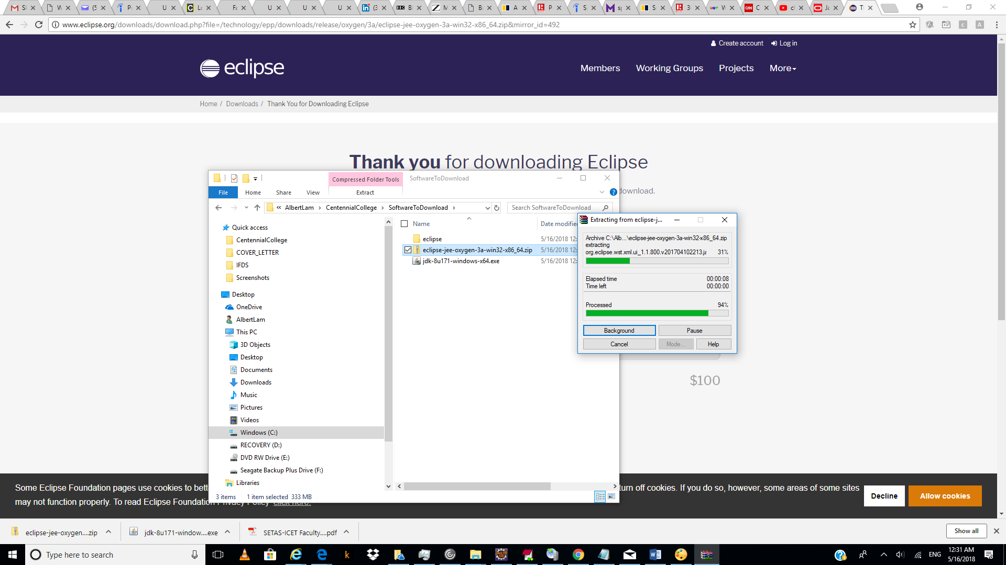

14.)

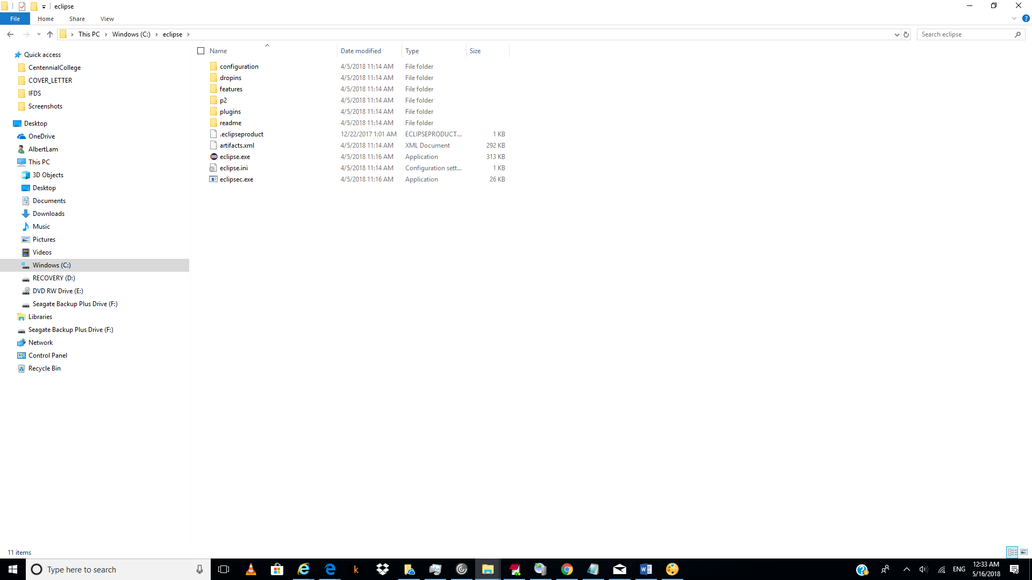

Copy “eclipse” folder to root c drive.

15.)

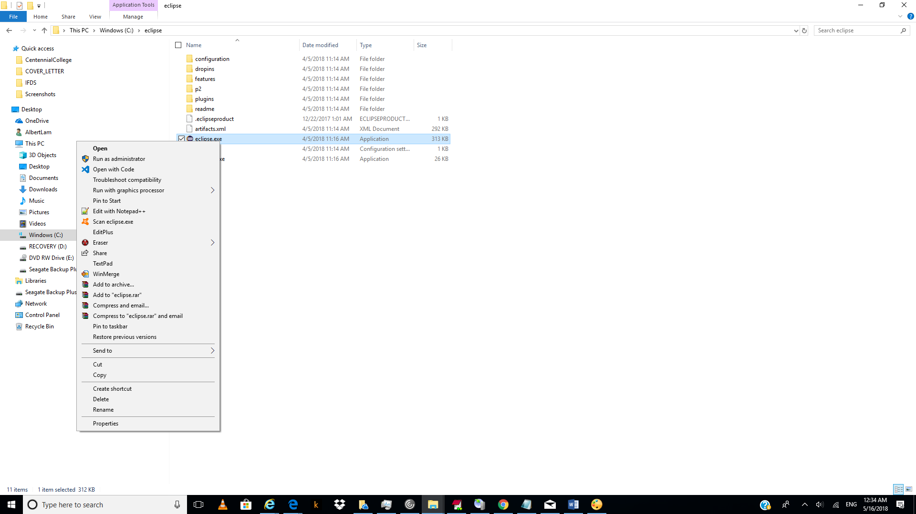

15.)

Double click on “C:\eclipse\eclipse.exe” file.

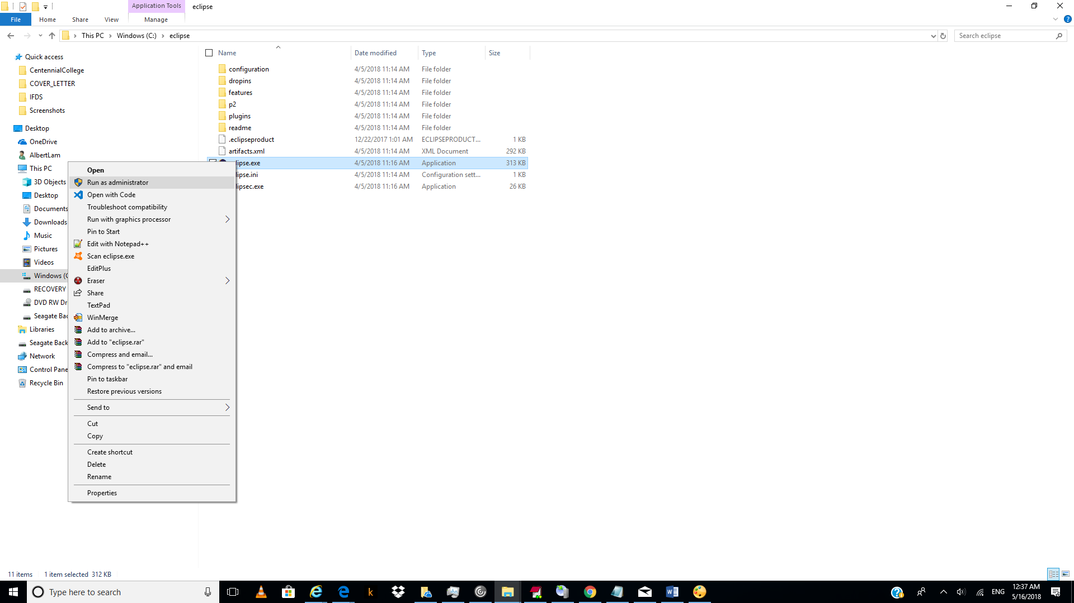

16.)

Click under “core” zip.

<https://tomcat.apache.org/download-90.cgi>

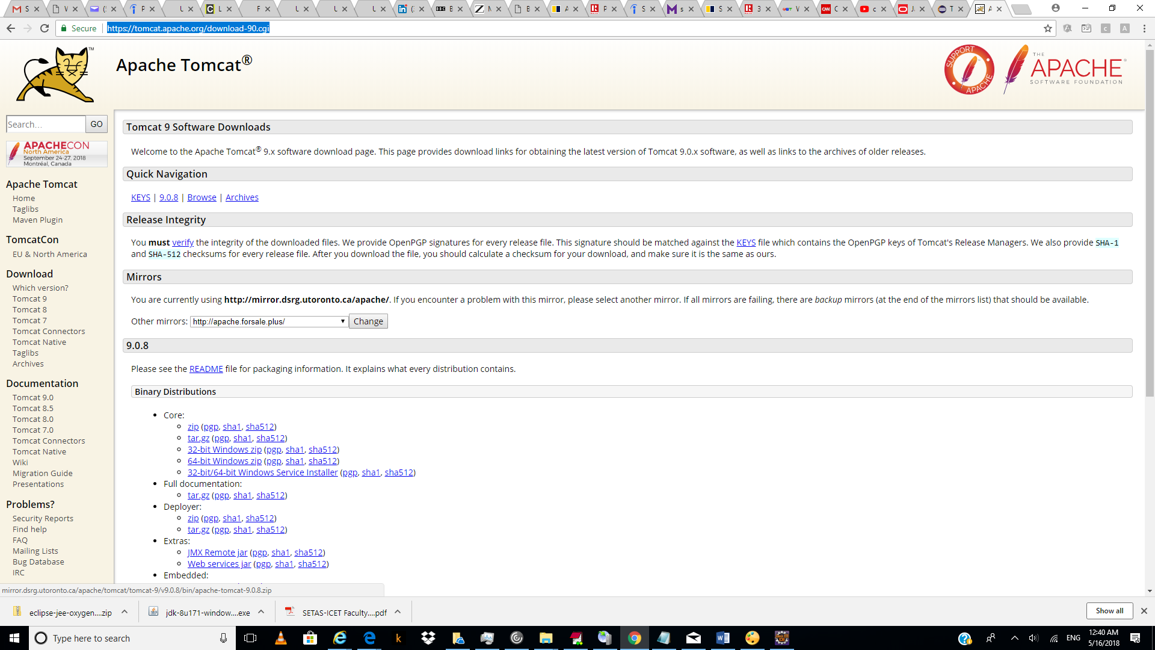

17.)

Unzip apache-tomcat-9.0.8.zip

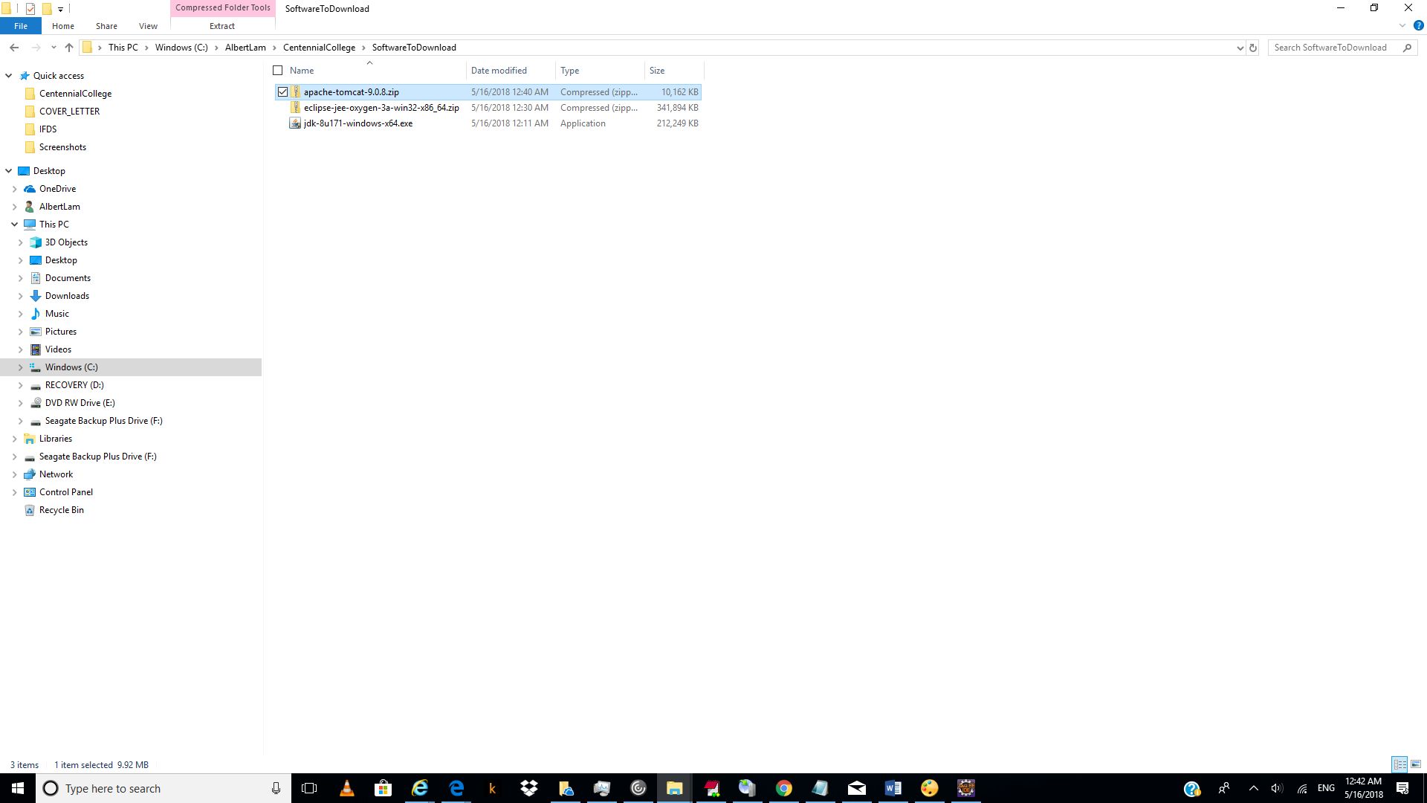

18.)

Rename folder apache-tomcat-9.0.8 to tomcat9 and copy to root c drive.

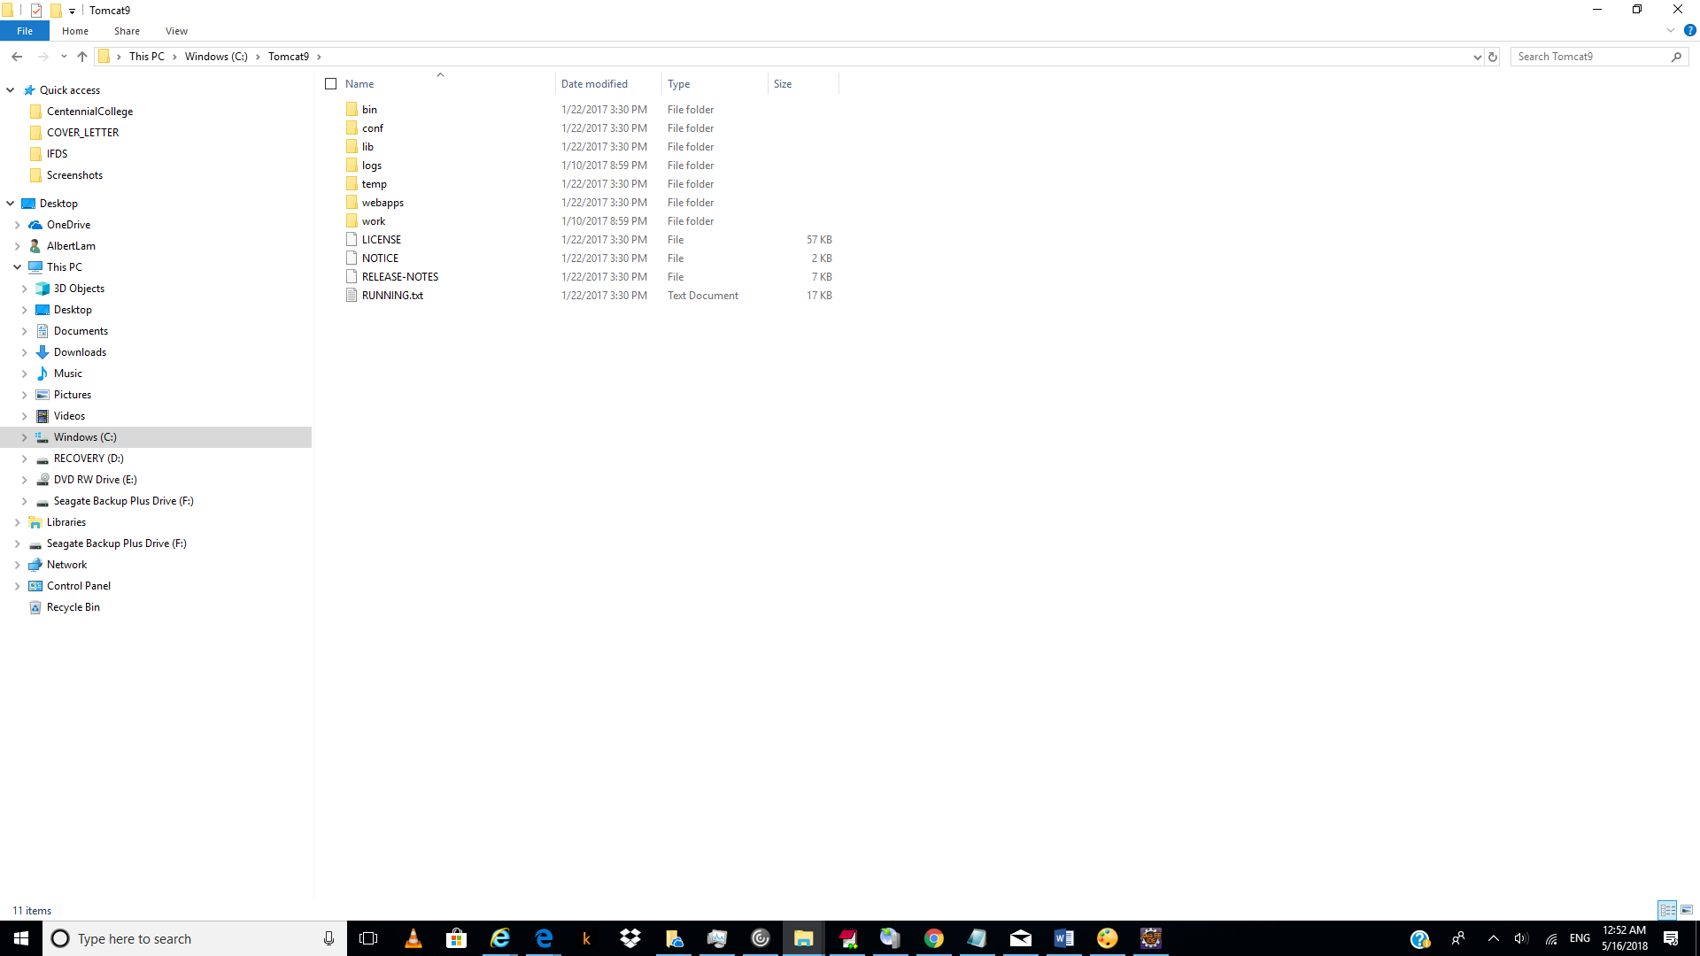

19.)

Download my sql:

<http://www.mediafire.com/file/rb1xx9zfz54ubi8/Portable.Mysql.5.5.13-Very.Small.rar>

Unzip it Portable.Mysql.5.5.13-Very.Small.rar

20.)

And copied the result to c drive root.

C:\Portable.Mysql.5.5.13-Very.Small\bin

How to start Mysql:

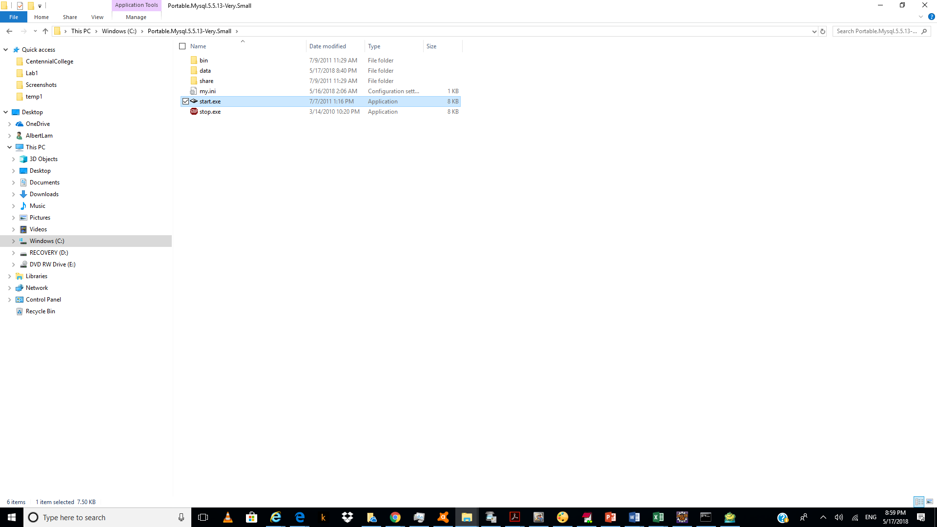

Click “start.ext”.

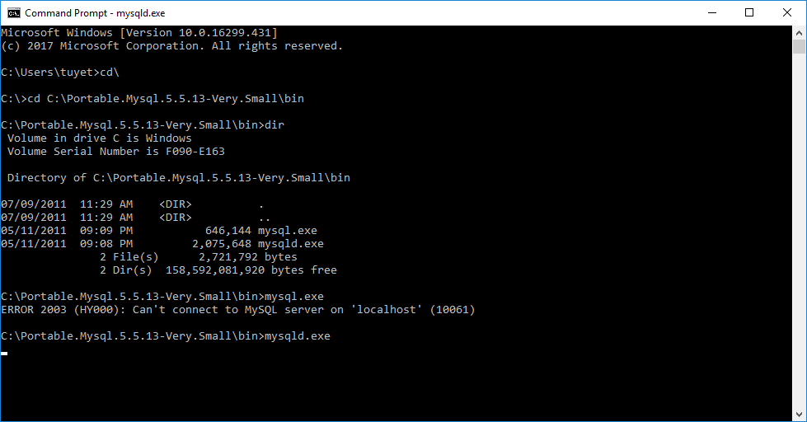

21.)

Download toad for mysql freeware:

ToadforMySQL_Freeware_7.3.1.3290

Click “download now”.

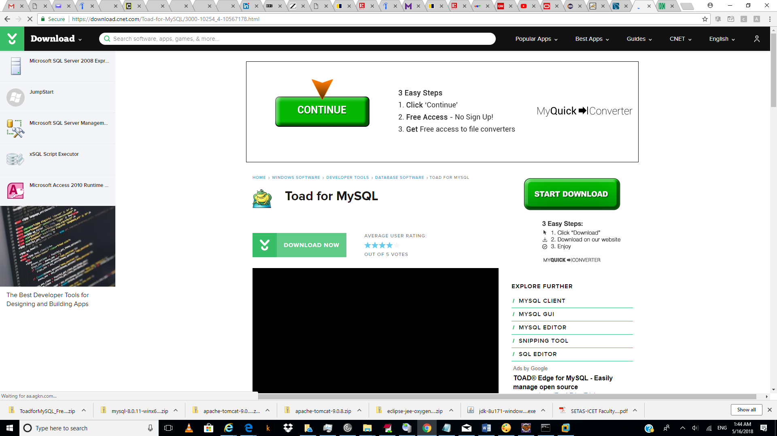

22.)

Unzip ToadforMySQL_Freeware_7.3.1.3290.zip

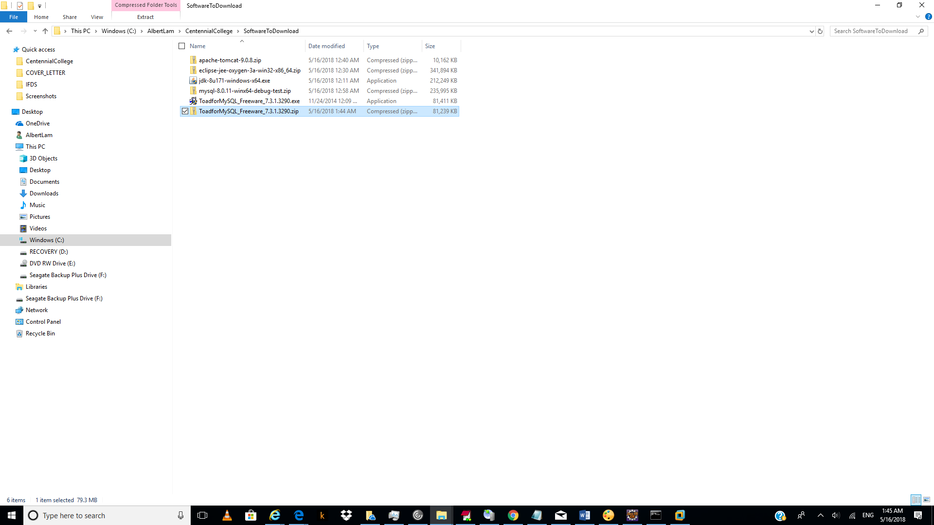

23.)

Click “next”.

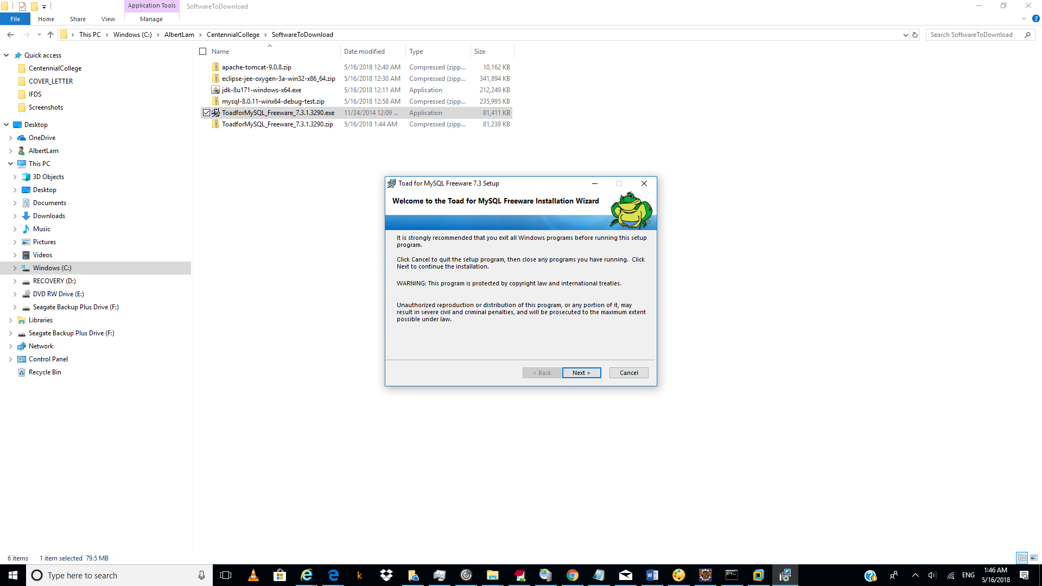

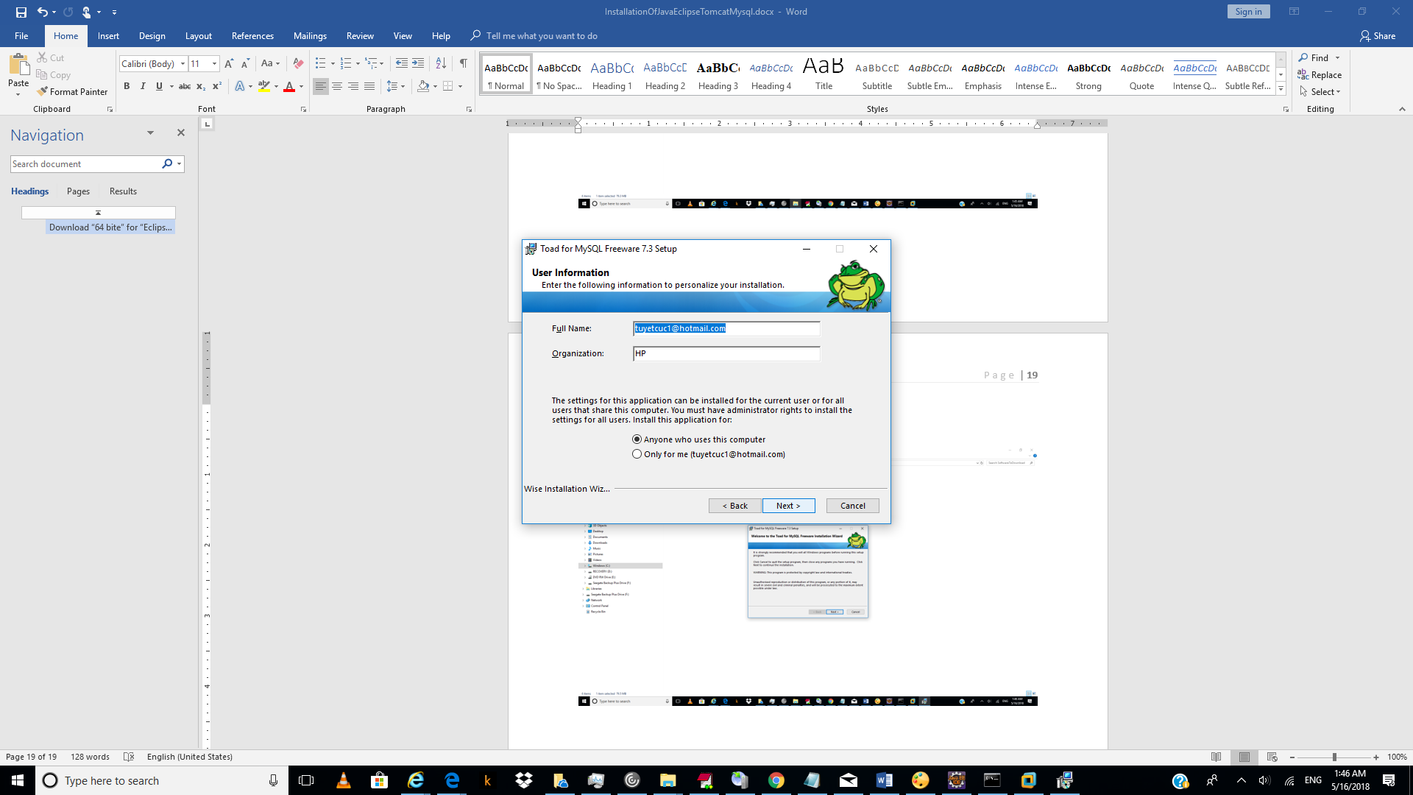

Click “Next”.

24.)

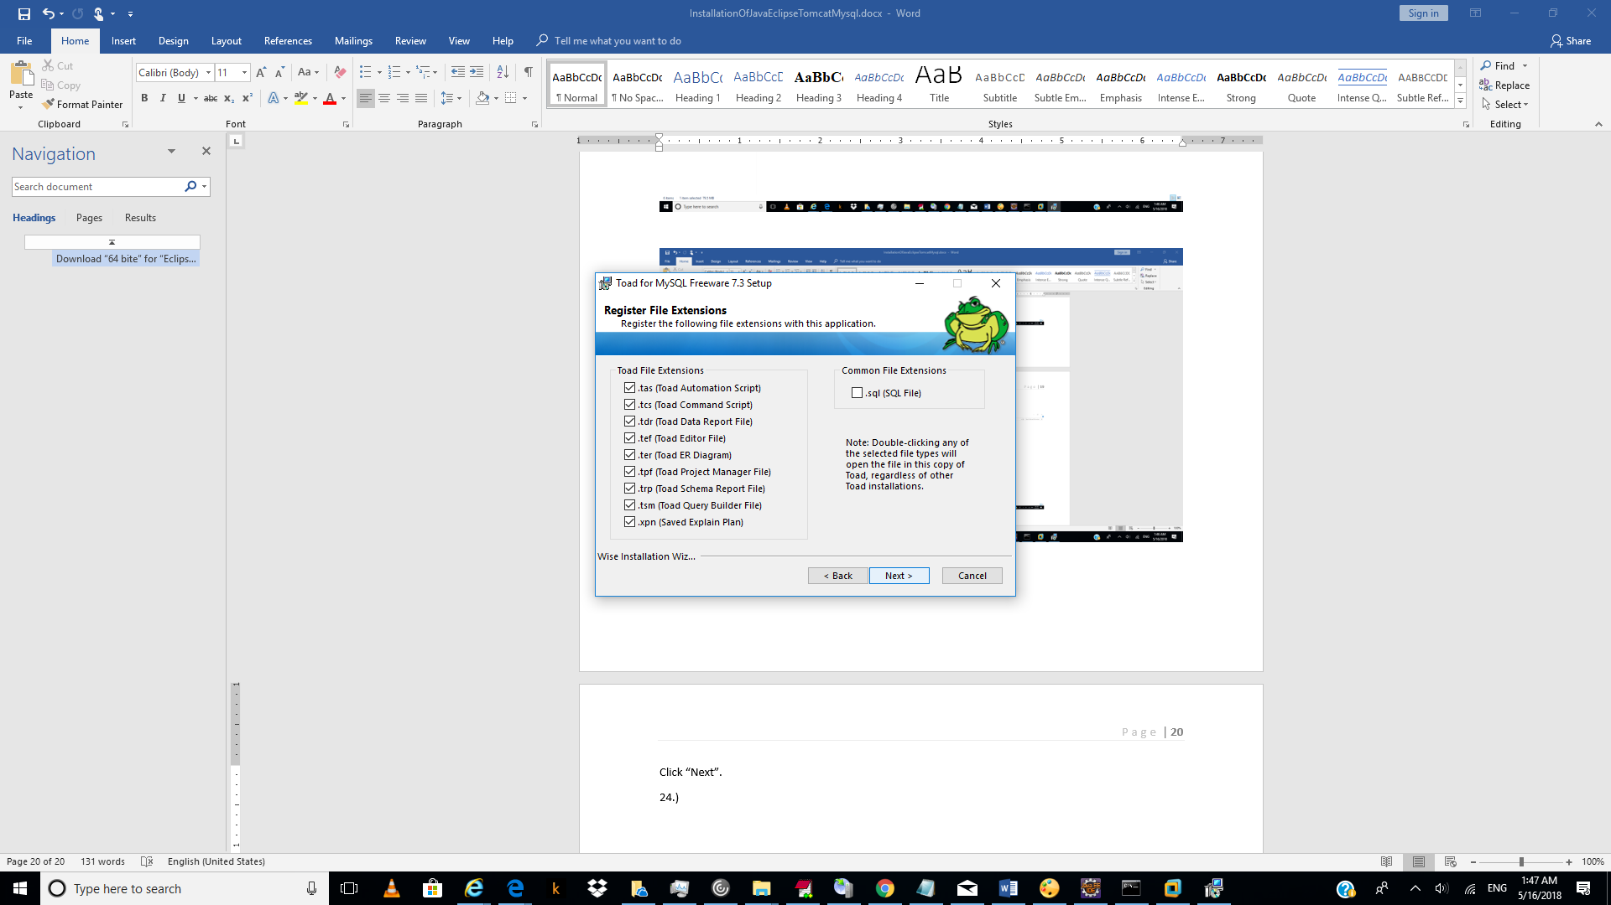

25.)

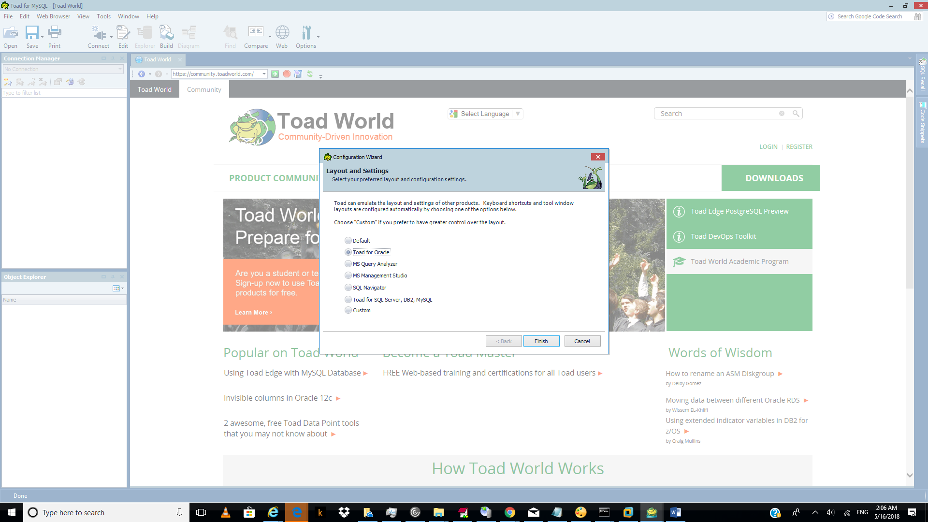

26.)

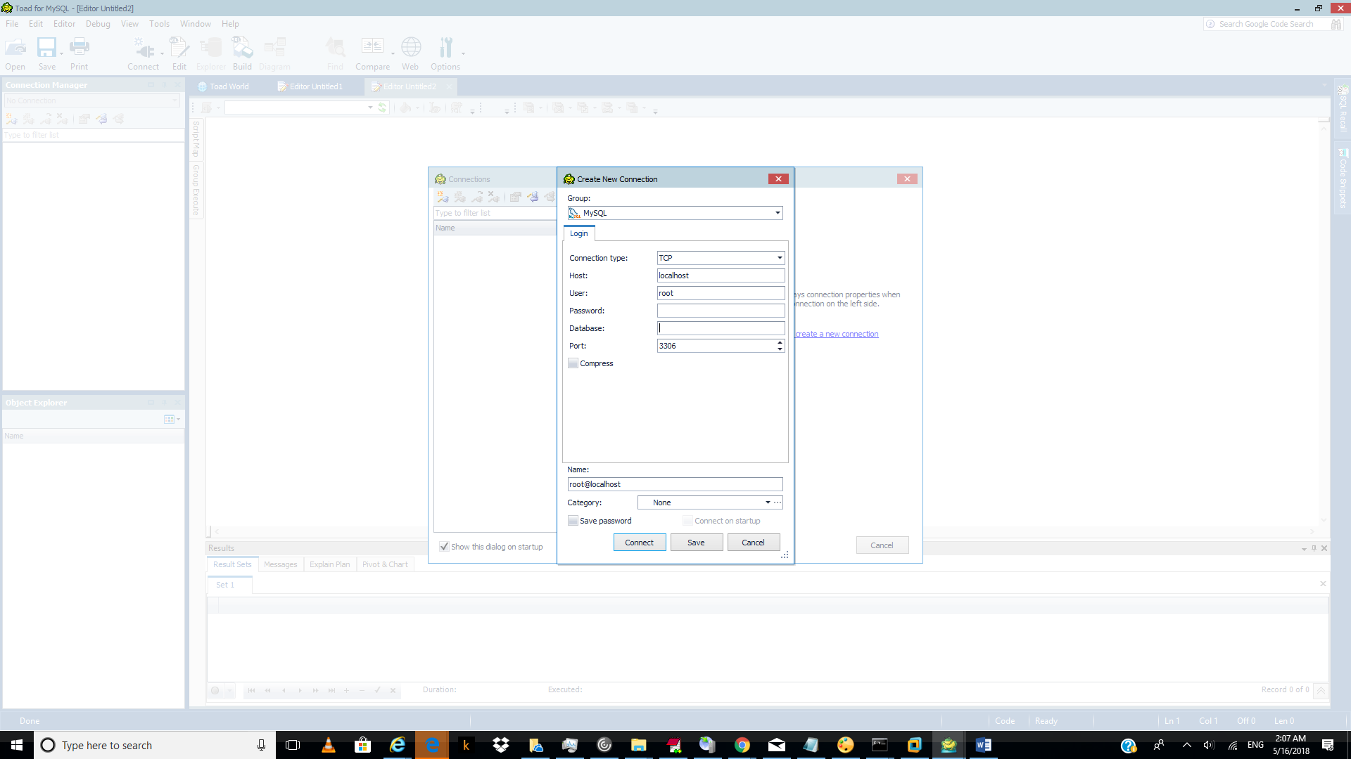

27.)

On the “c” drive created the following folder:

C:\workspace-Centennial-May2018

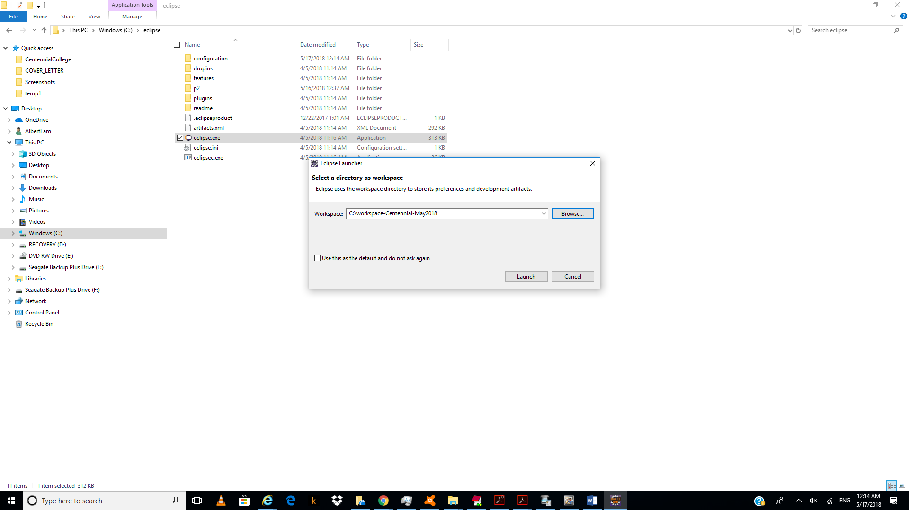

28.)

Go to “windows/preference”:

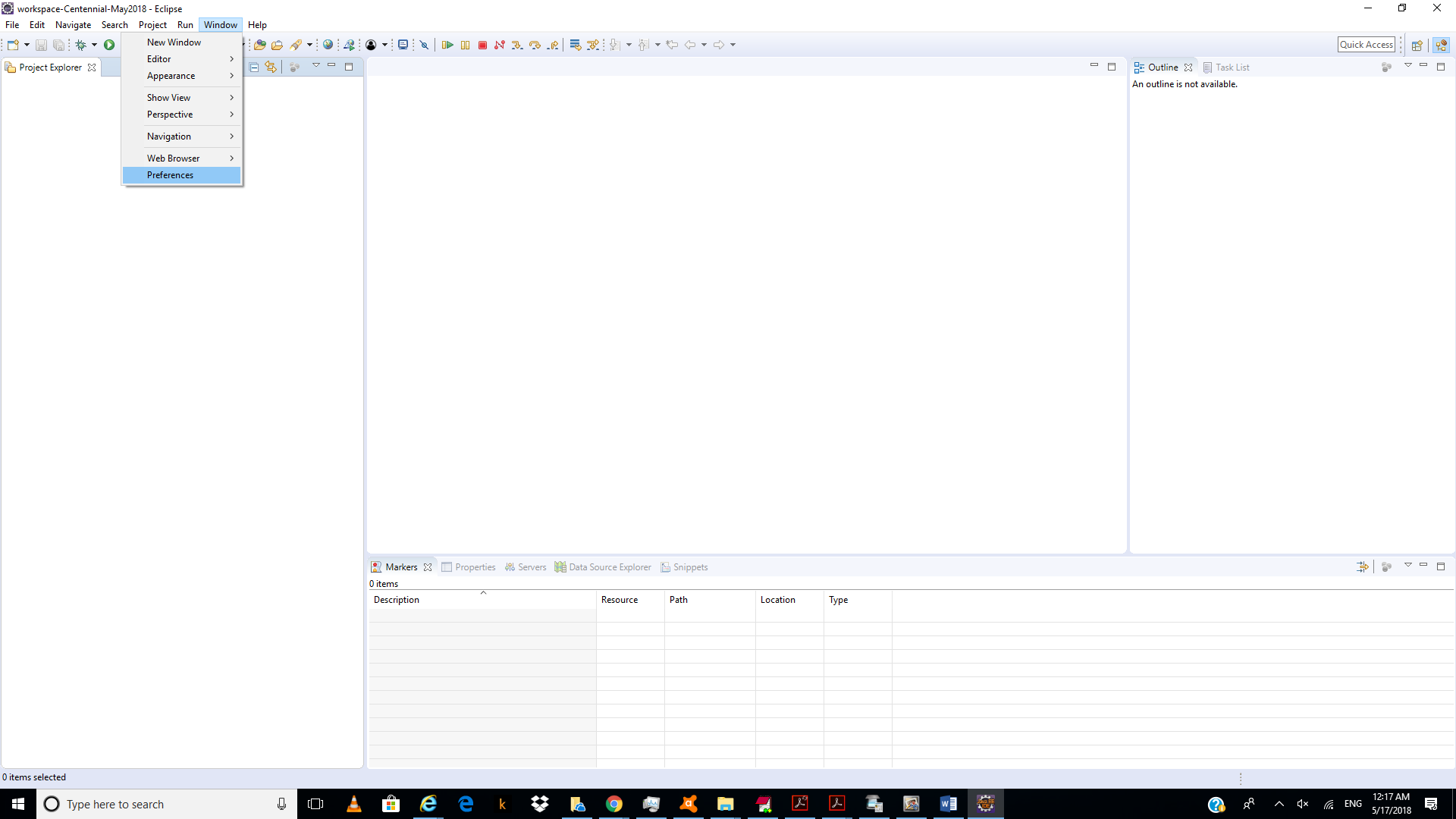

29.)

Click “server/runtime”:

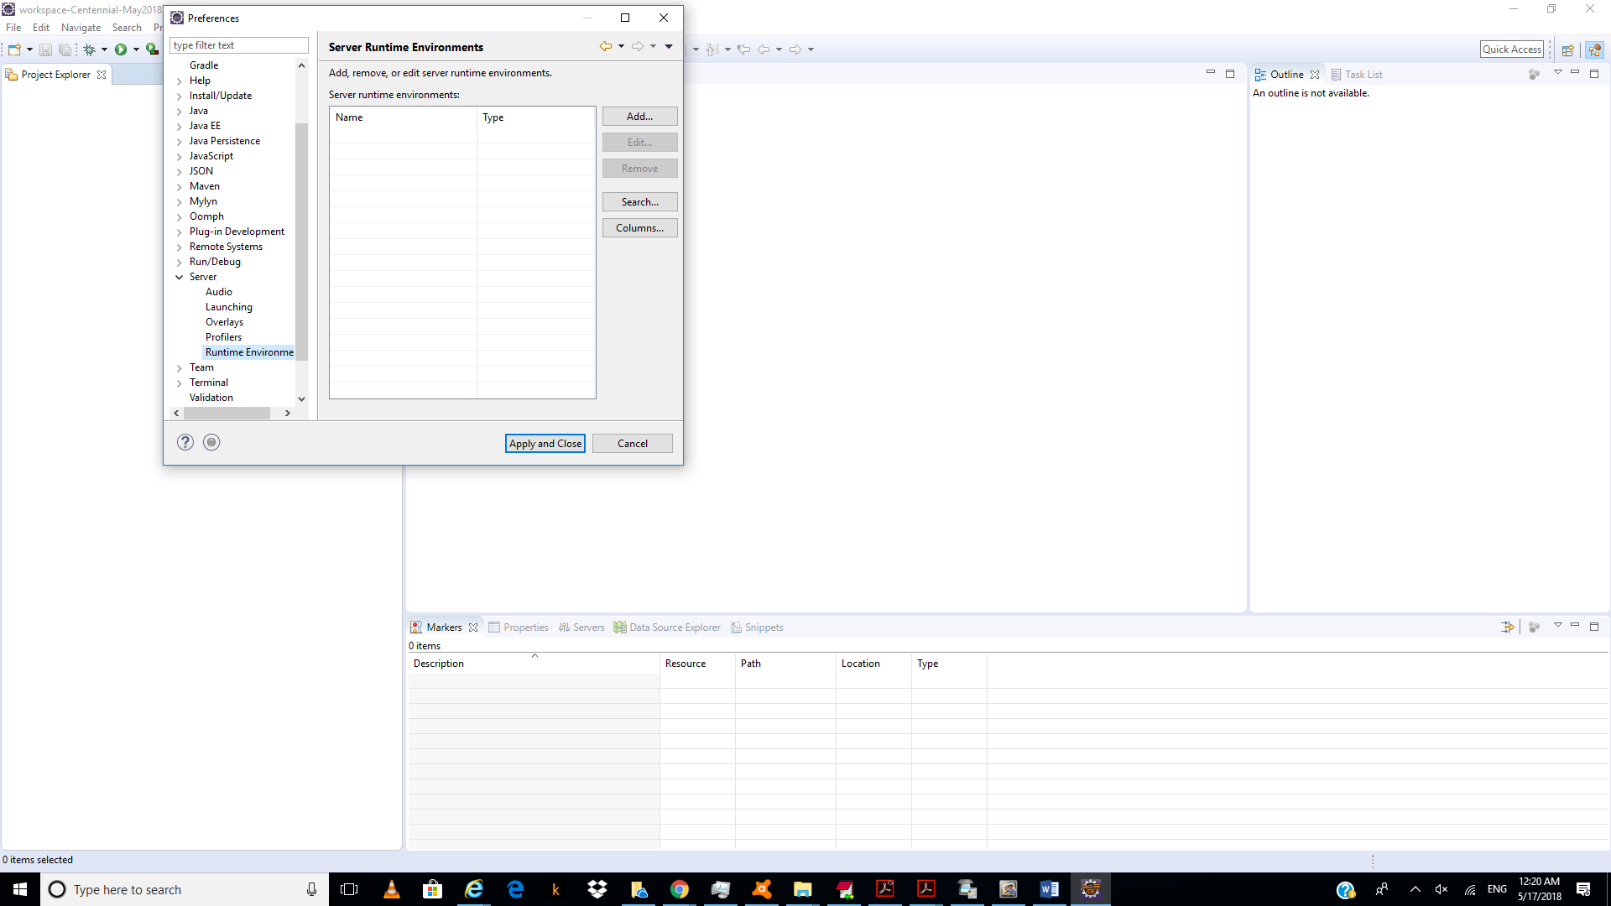

Click “add”.

30.)

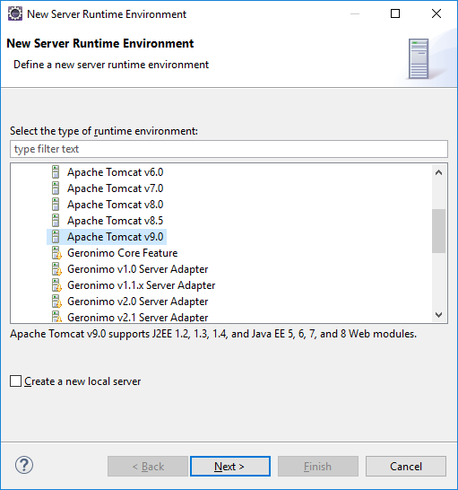

Choose “tomcat 9”.

31.)

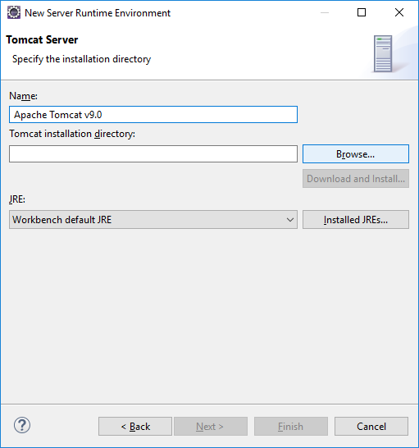

Click “browse”.

32.)

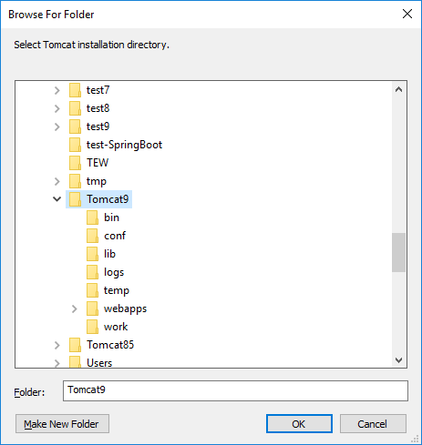

33.)

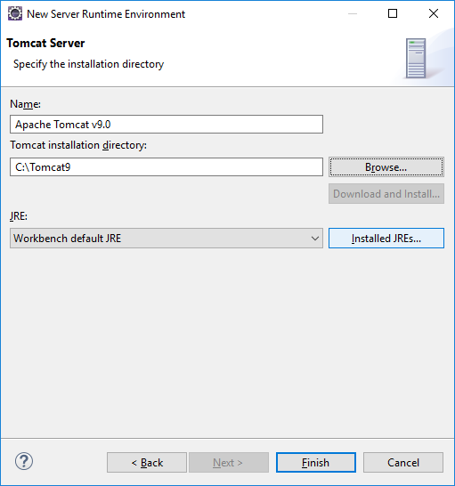

Click “installed jres”.

34.)

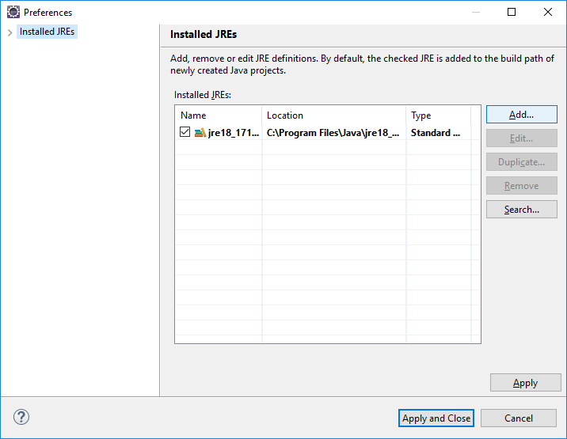

Click “add..”.

35.)

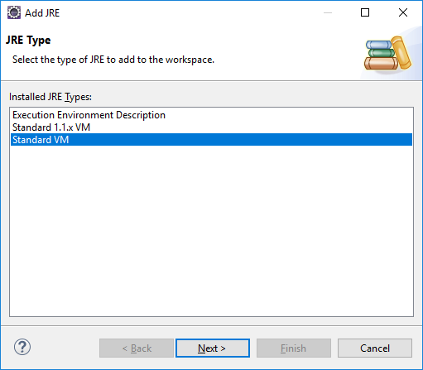

Click “next”.

36.)

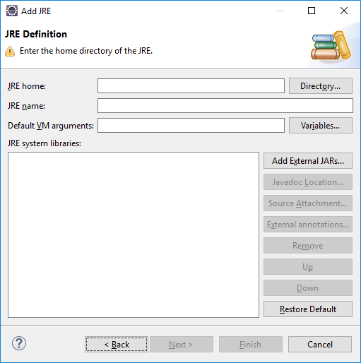

Click “Drectory”.

37.)

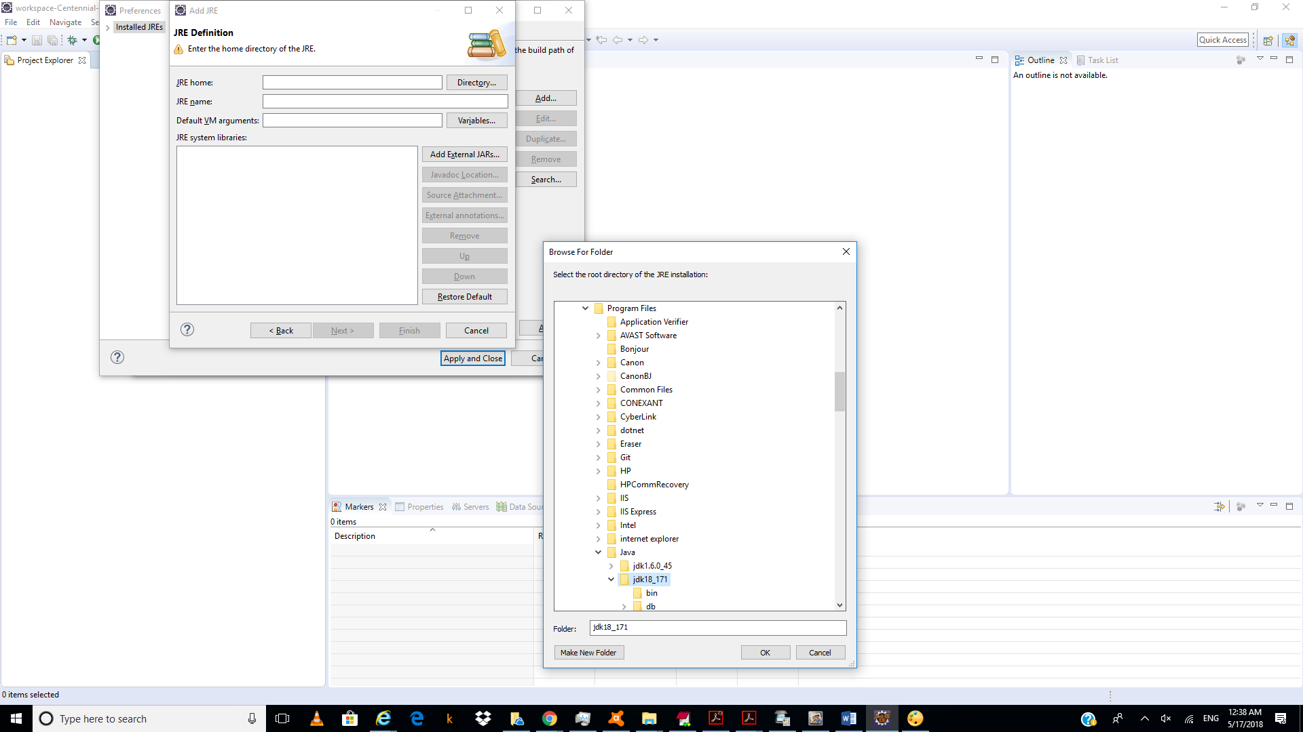

38.)

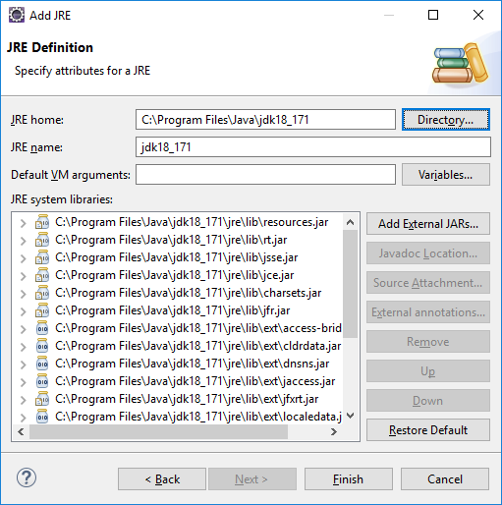

Click “Finish”.

39.)

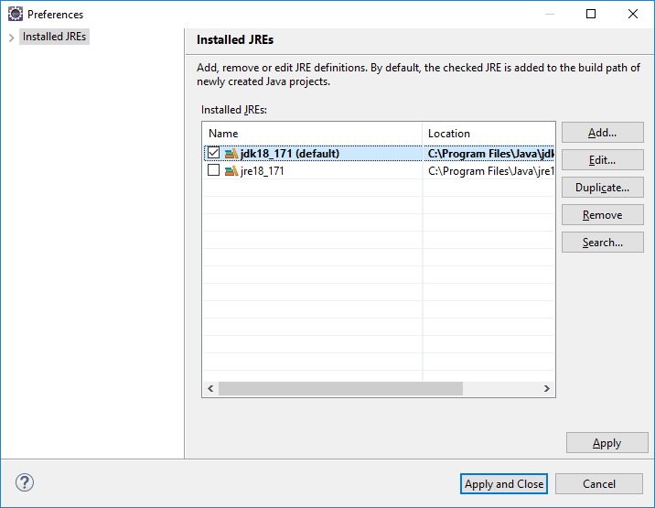

Click first checkbox and click “apply and close”.

40.)

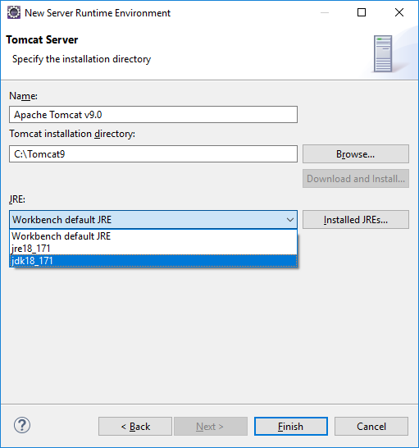

Change jre drop-down to “jdk18_171”.

Click “finish”.

41.)

Click “apply and close”.

42.)

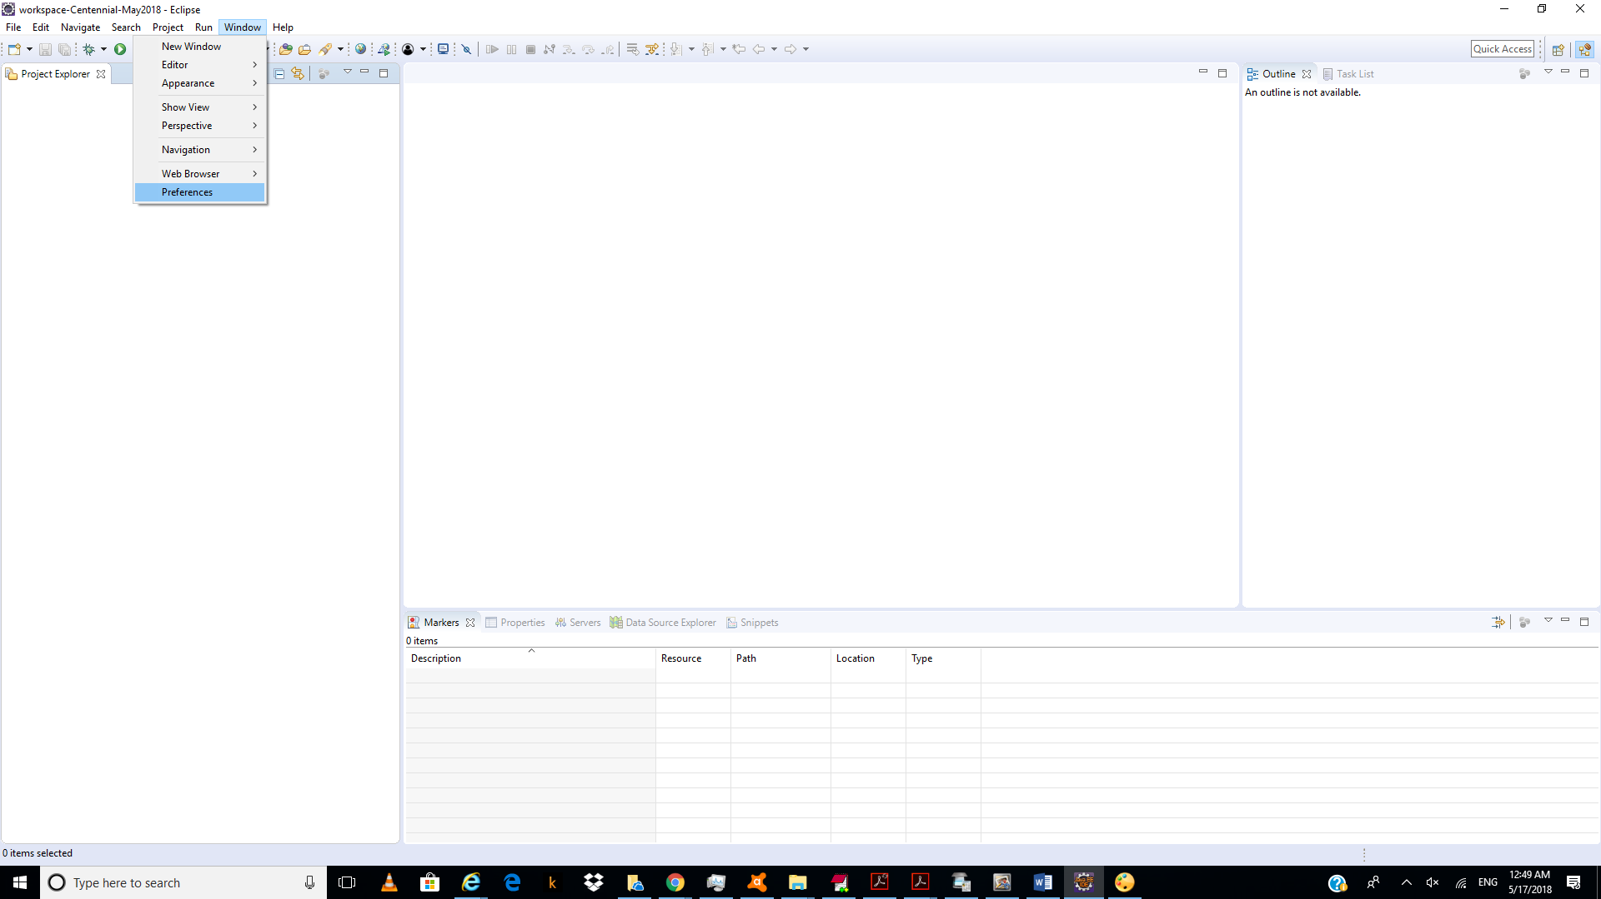

Click “Windows/preference”.

43.)

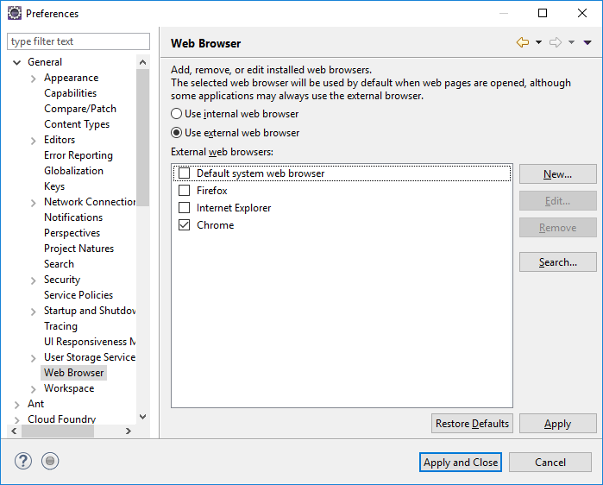

Click “General/Web Browser/”

Click “Use external web browser”.

Click “chrome”.

43.)

Click “file/dynamic web project”.

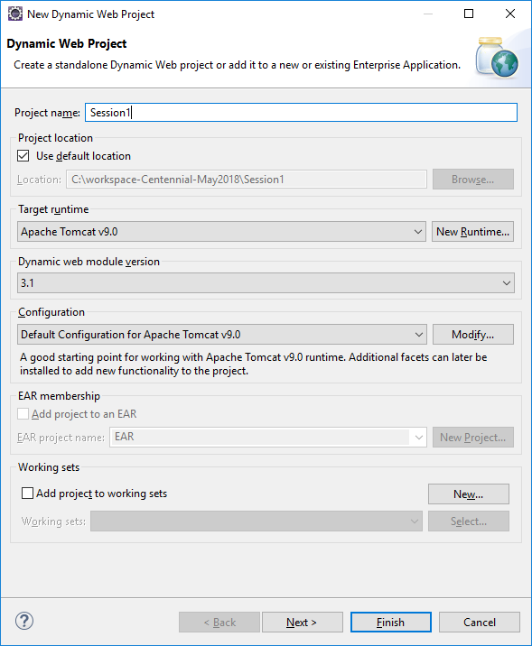

Type “session1” click “next”.

44.)

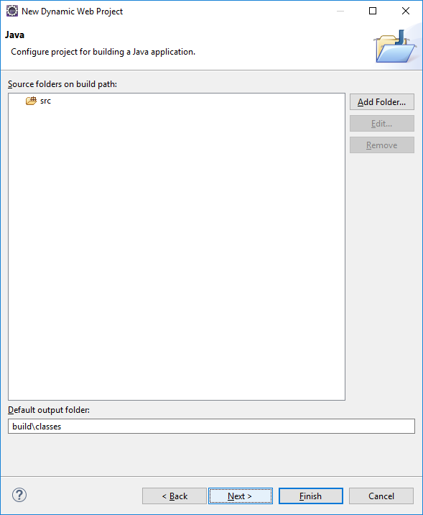

Click “next.

45.)

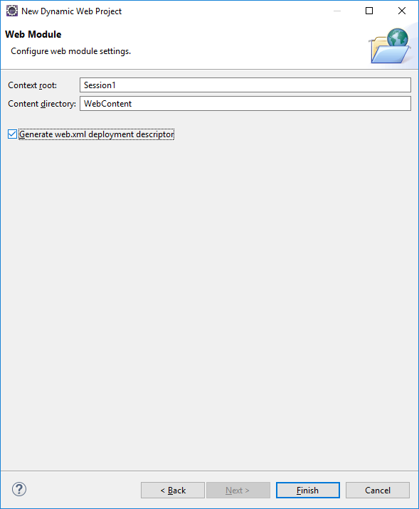

Click “Generate web.xml deployment descriptor”.

46.)

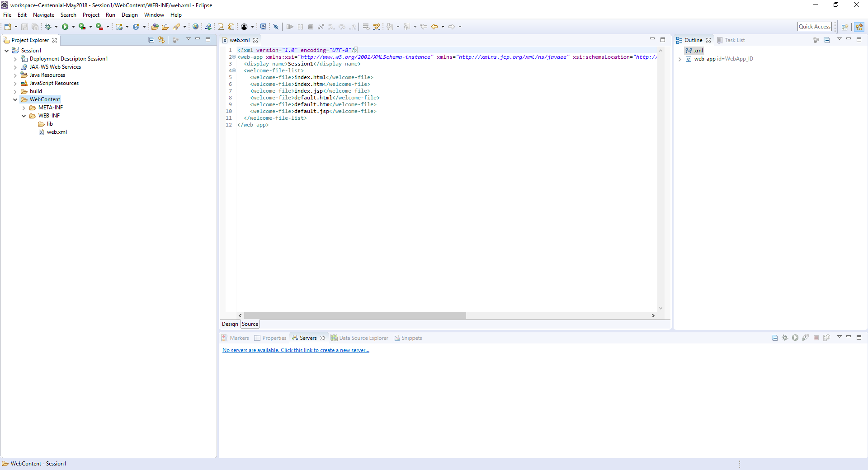

Under “web content” click “file/new/index.html”.

47.)

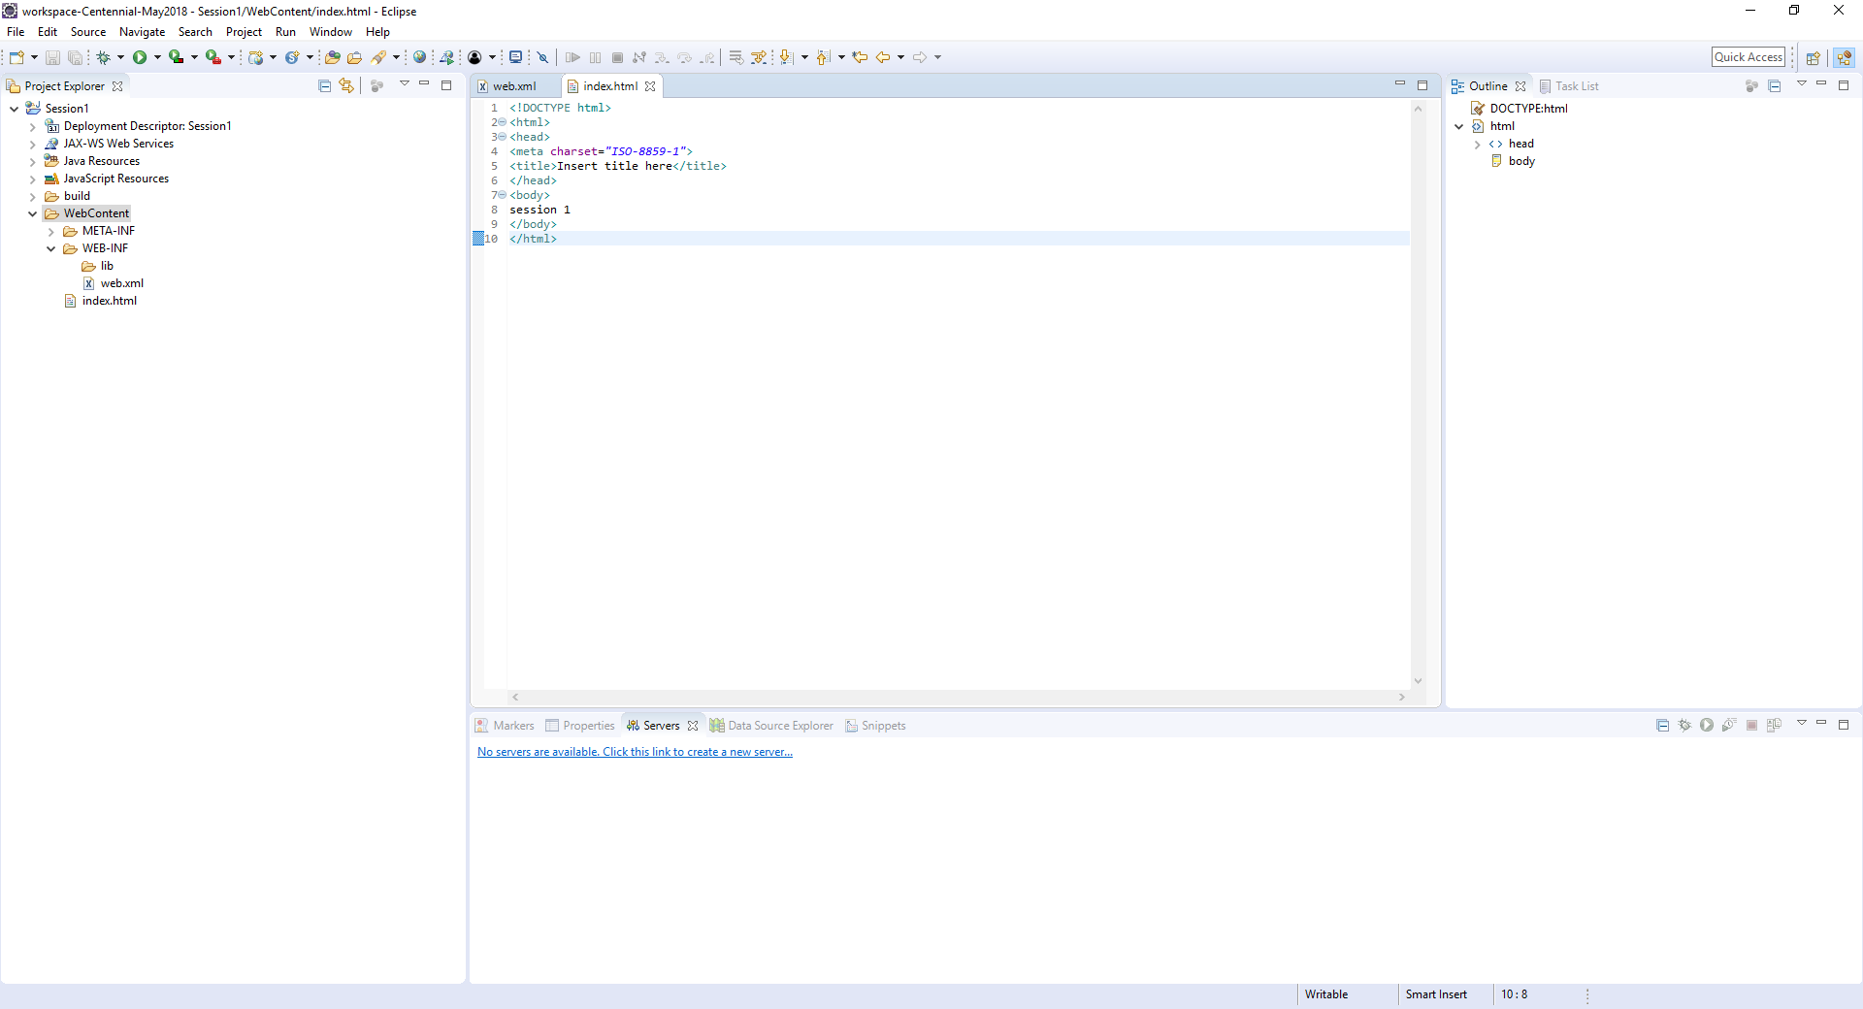

48.)

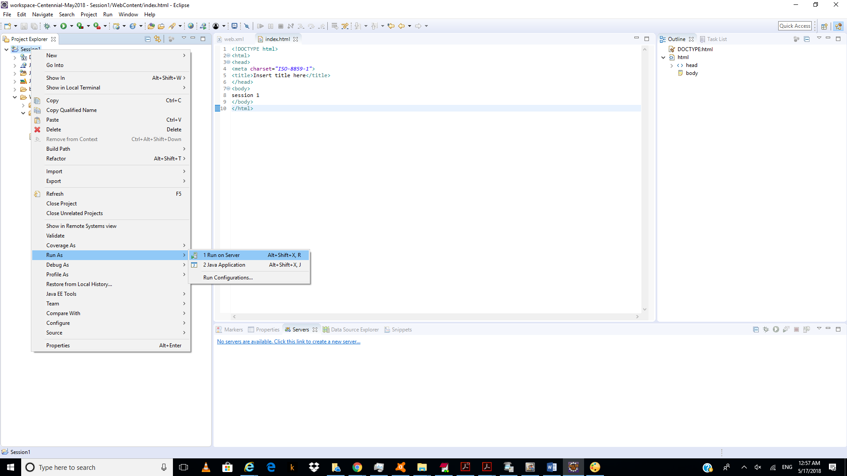

Right click on “session1” and choose “run on server”.

47.)

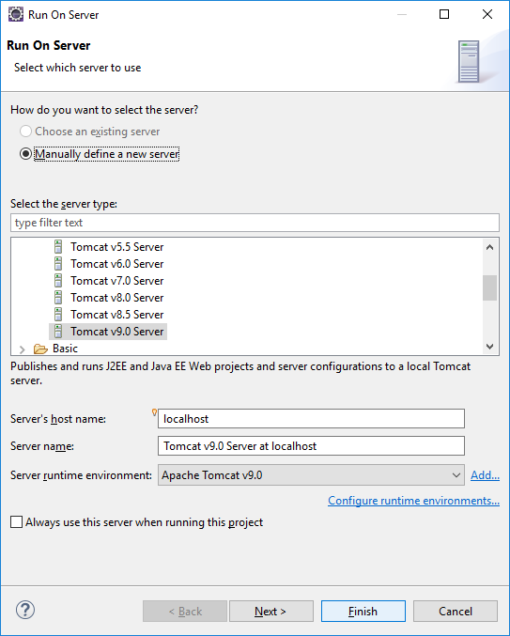

Click “finish”.

48.)

Click “allow”.

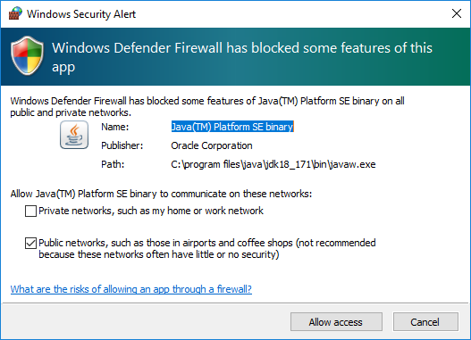

49.)

